TASK 16:

* Create a Virtual Machine
* Install FTP server on the Virtual Machine
* Try to connect to it using FileZilla

Steps to create VM and install FTP server and then check connectivity using FileZilla:

Step 1: Create Virtual machine ‘vm-ftp’ using azure Virtual machine service.

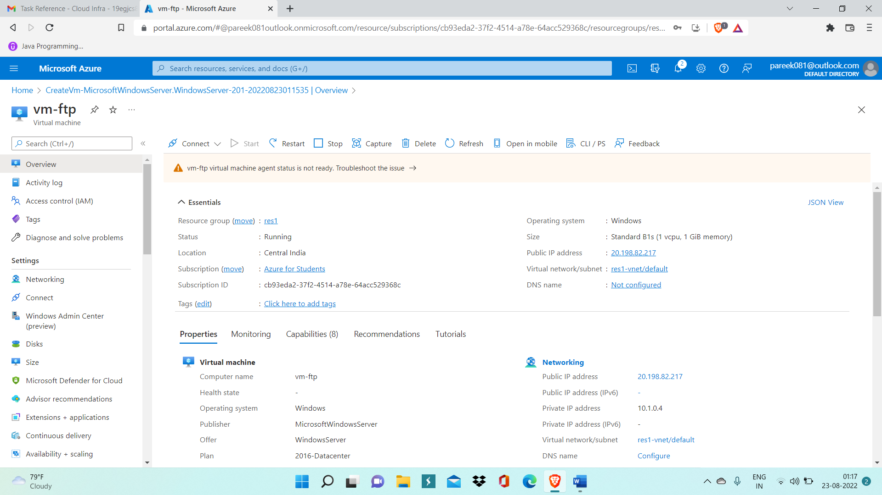

Step 2: Now, open Server Manager inside VM and open Add roles and Features wizard

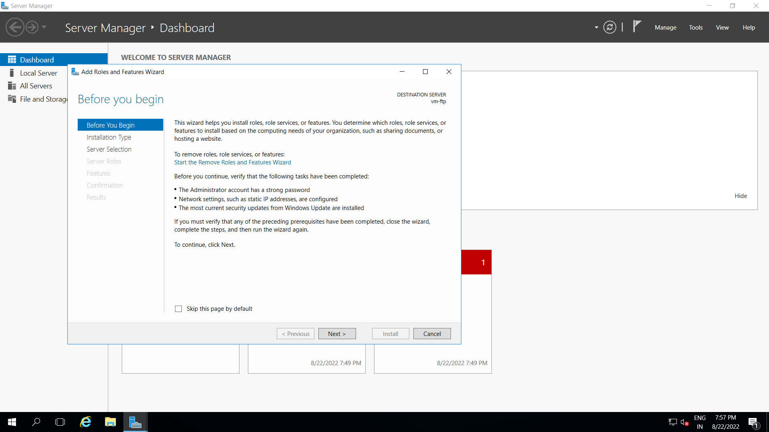

Step 3: Now install FTP server.

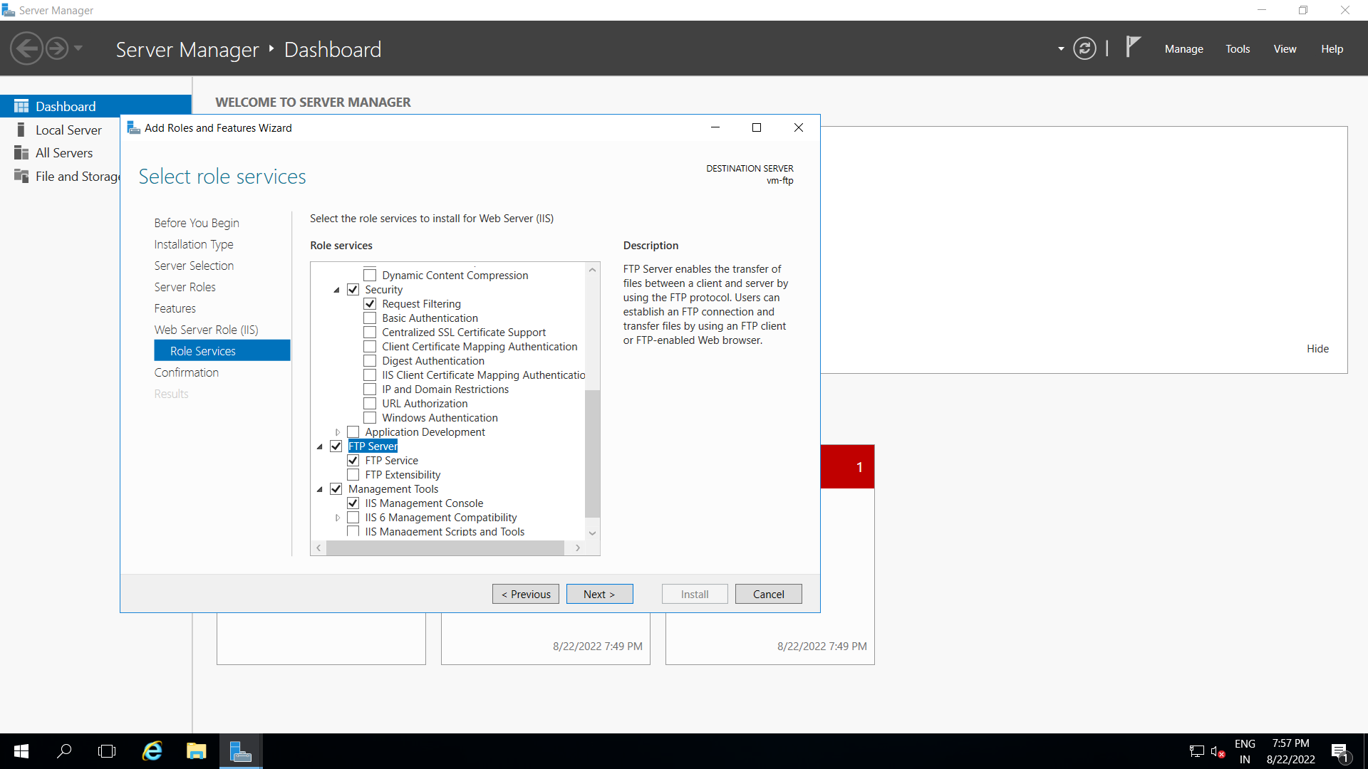

Step 4: GO inside IIS manager and Add New FTP site.

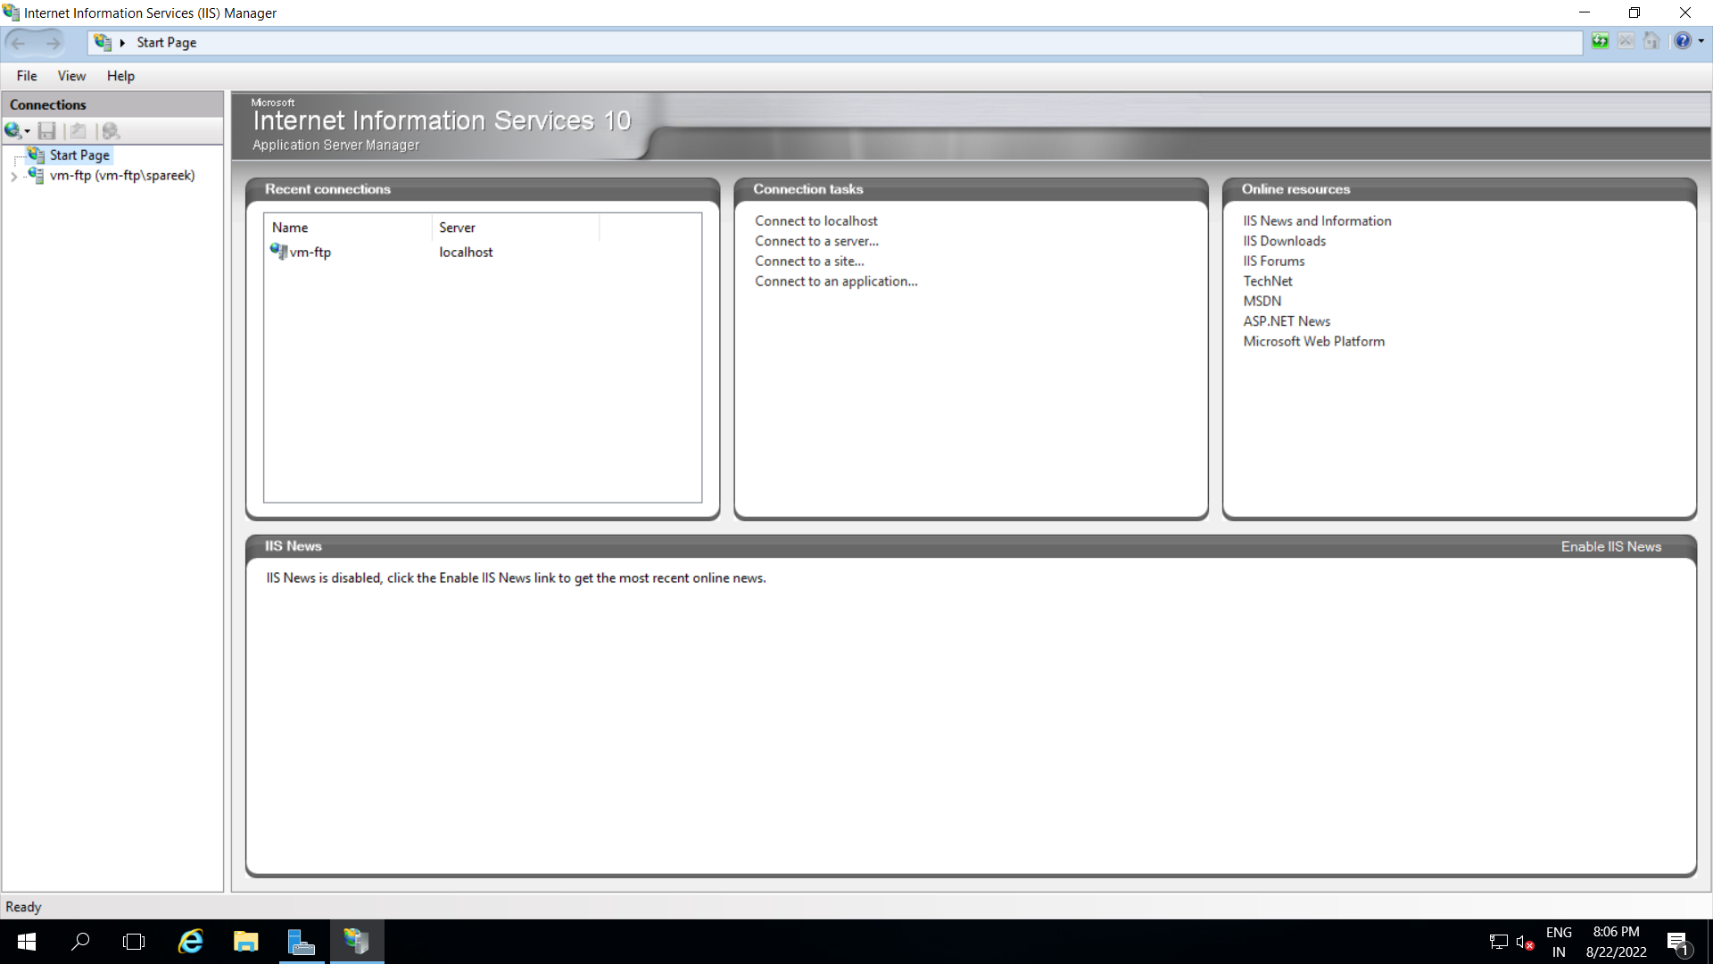

Step 5: Enter ftp site information and finish.

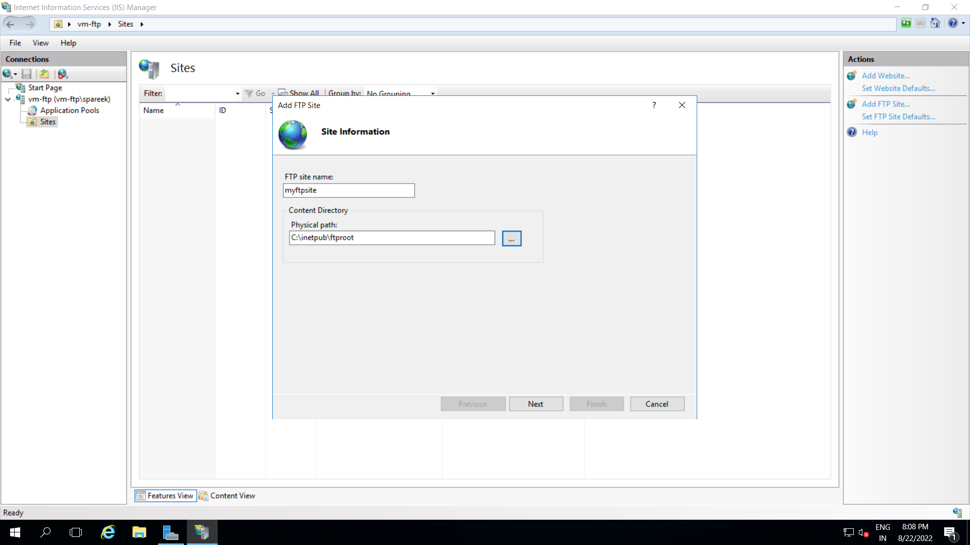

Step 6: Now, open FTP firewall support and enter port range and IP address.

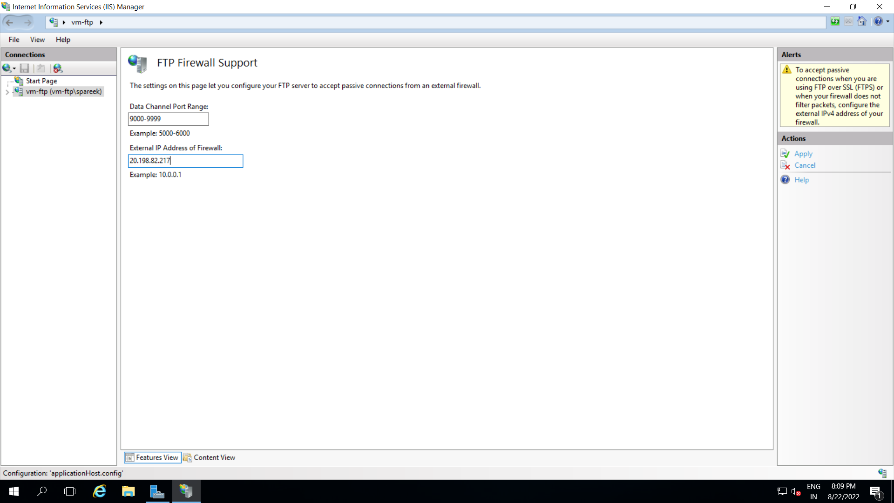

Step 7: Now go inside Networking of your VM and add inbound port for FTP in port 21.

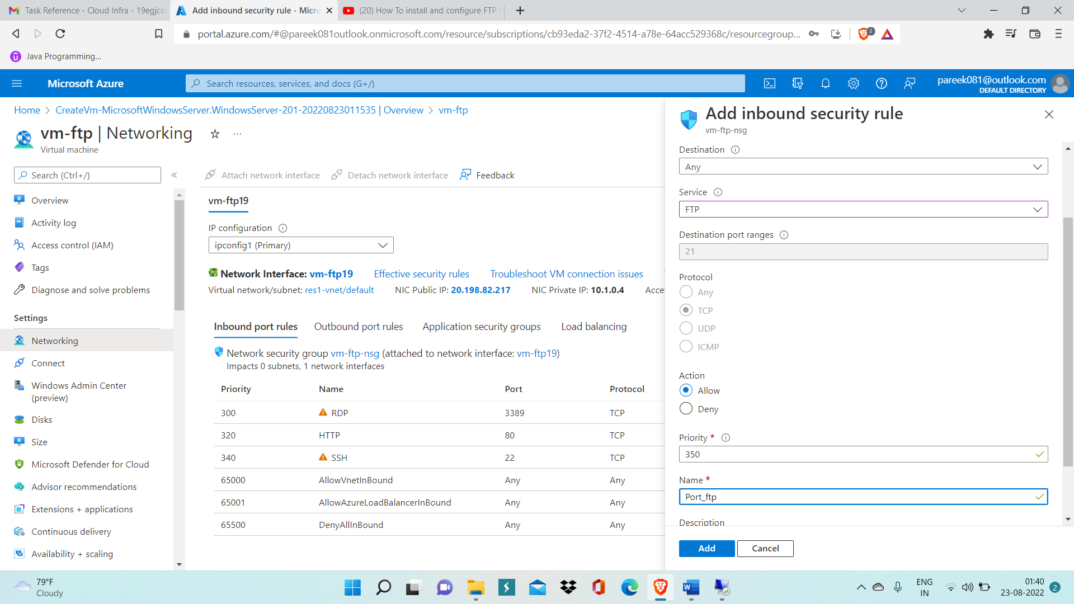

Step 8: Download FileZilla inside your VM and run its setup.

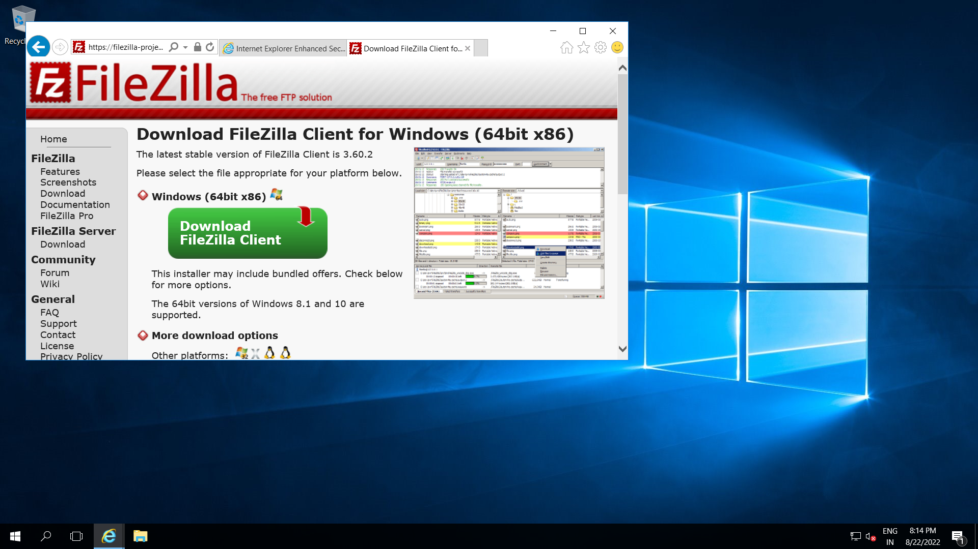

Step 9: Now inside command prompt and write command ‘netsh advfirewall set global statefulftp enable’

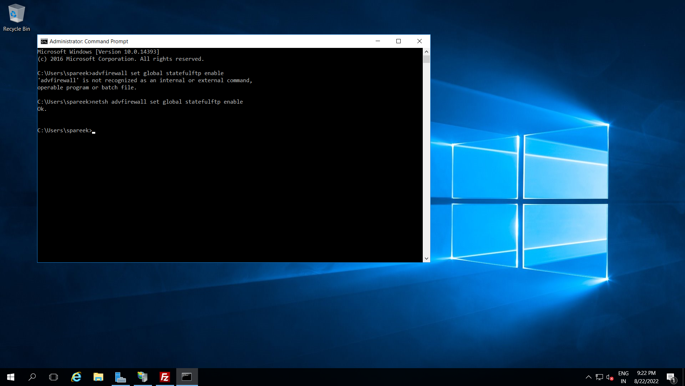

Step 10: Now inside FileZilla, check connectivity.

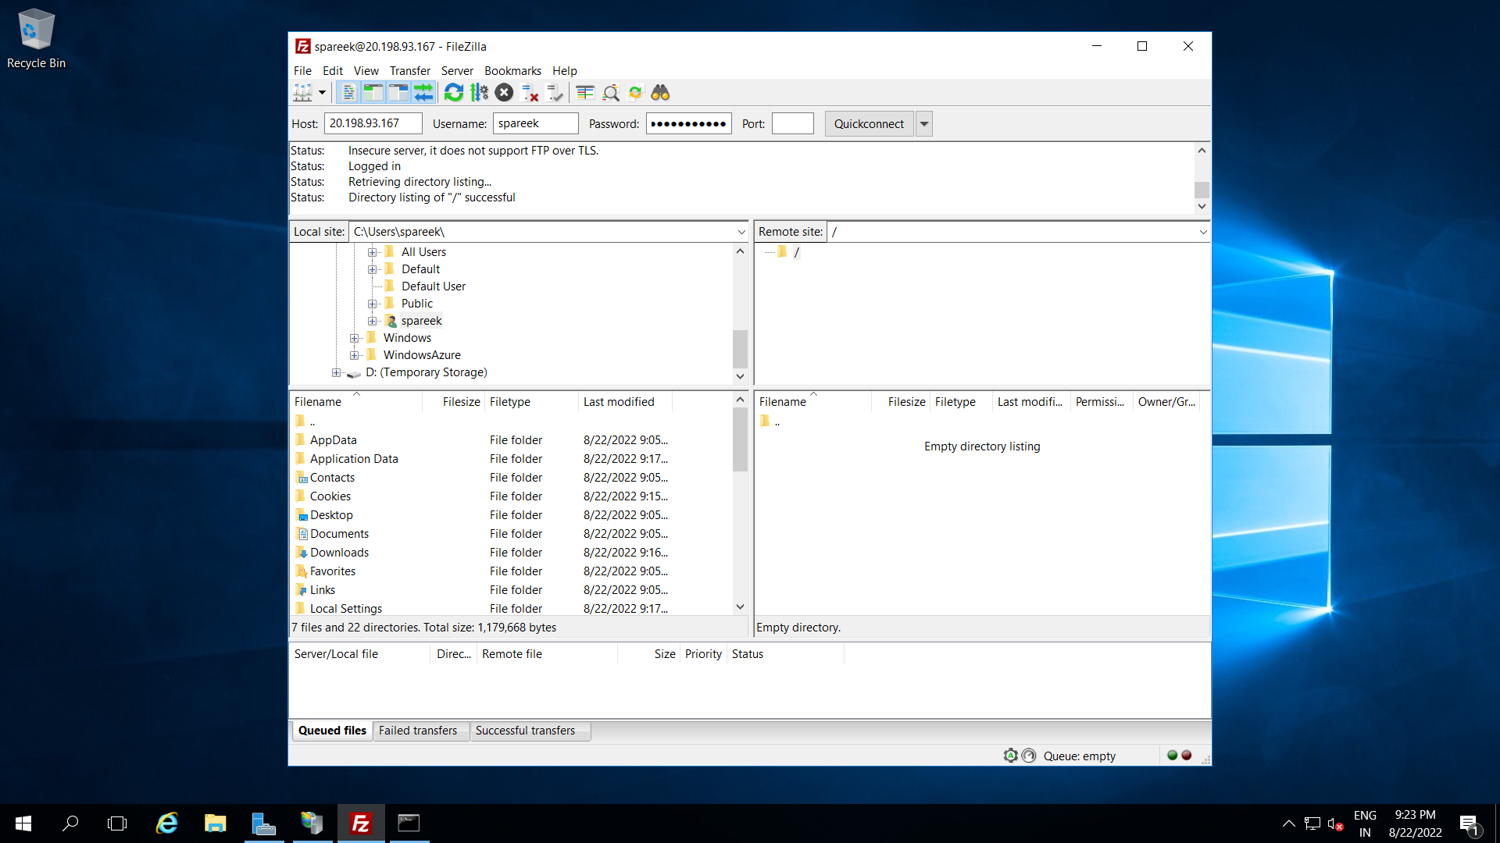

Above image of filezilla client shows that ftp server is properly connected.